**Tropical Fish Intl Ltd**

**OPR FOR LOGISTIC SHIPMENT CHECK LIST**

|  |  |
| --- | --- |
| **SUBJECT** | **Obtain permits and approvals from Relevant Departments** |
| **DEPARTMENT** | **Logistic Colombo** |
| **RECORDER (Name & Designation)** | **Ranjith Seevaratnem, Priyadarsha, Udaya Perera** |
| **APPROVEDBY (Name & Designation)** | **Udaya Perera** |
| **CREATED DATE** | **28/04/2016** |
| **LAST UPDATED** |  |
| **PATH ON NETWORK FOLDER** | **Z:\Gen Log\OPR** |
| **NO. OF PAGES INCLUDING THIS PAGE** | **5** |

1. BOI

1.1 BOI (Imports for Breeding/ Fresh Water)

a). Request Letter from Importer

b). Shippers Performa Invoice

c). Import Export details

1.2 BOI Imports for Re export

a). Request Letter from the Importer

b) Shippers Performa Invoice

c). Import Export details

2 NAQDA (Obtain License for Live Rock)

2.1. Request Letter from Shipper to NAQDA office (Harvest request)

2.2. Harvesting serial numbers statement received from NAQDA regional office.

2.3. Documents for previous shipments (CUSDEC, AWB)

3 Fisheries Ministry

* 1. Export

1. Filled Application form
2. Request Letter
3. Import & Export Tracking details
   1. Import

a) Filled Application Form

1. Request Letter
2. Import & Export Tracking details
3. CUSDEC, AWB, Invoice
4. DAPH (Import of Fresh water fish for breeding)
   1. Quarantine Application,
   2. Copy of the Permit issued by the fisheries ministry
   3. Quarantine Site approval

4.4 Complete set of application along with supplier’s health certificates with Performa invoice

1. BOI

1.1 BOI (Imports for Breeding/ Fresh Water)

1. Request Letter from Importer



c) Import Export details

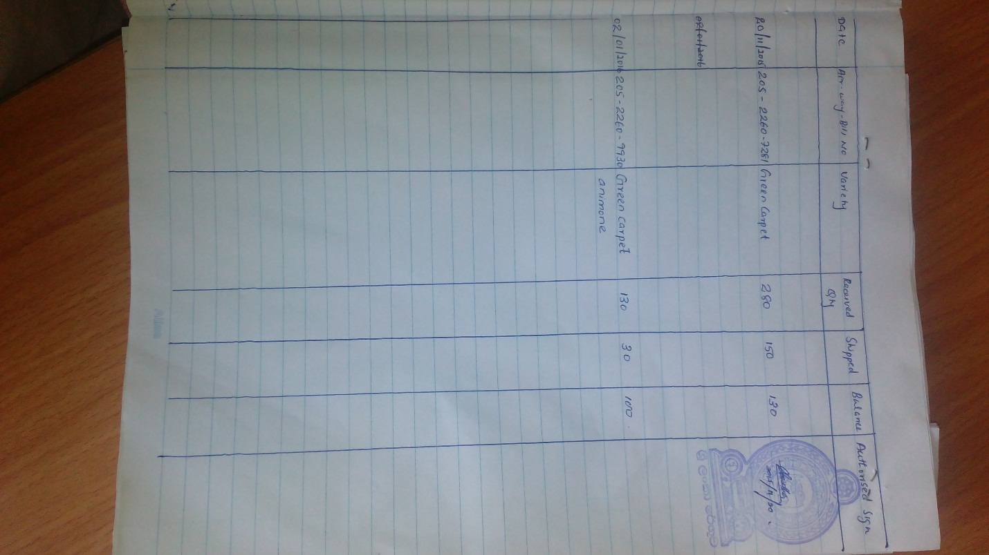

1.2 BOI Imports for Re export

a) Request Letter from Importer



1. Import Export details.



1. NAQDA (Obtain License for Live Rock

2.1 Request Letter from Shipper to NAQDA office (Harvest request)



* 1. Harvesting serial numbers statement received from NAQDA regional office

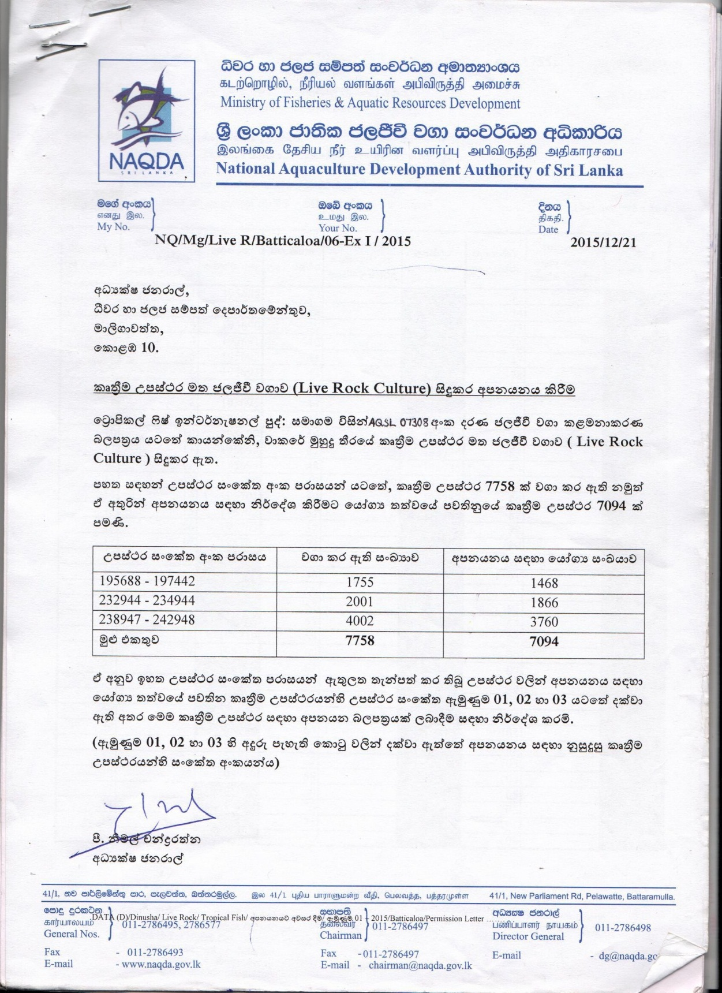

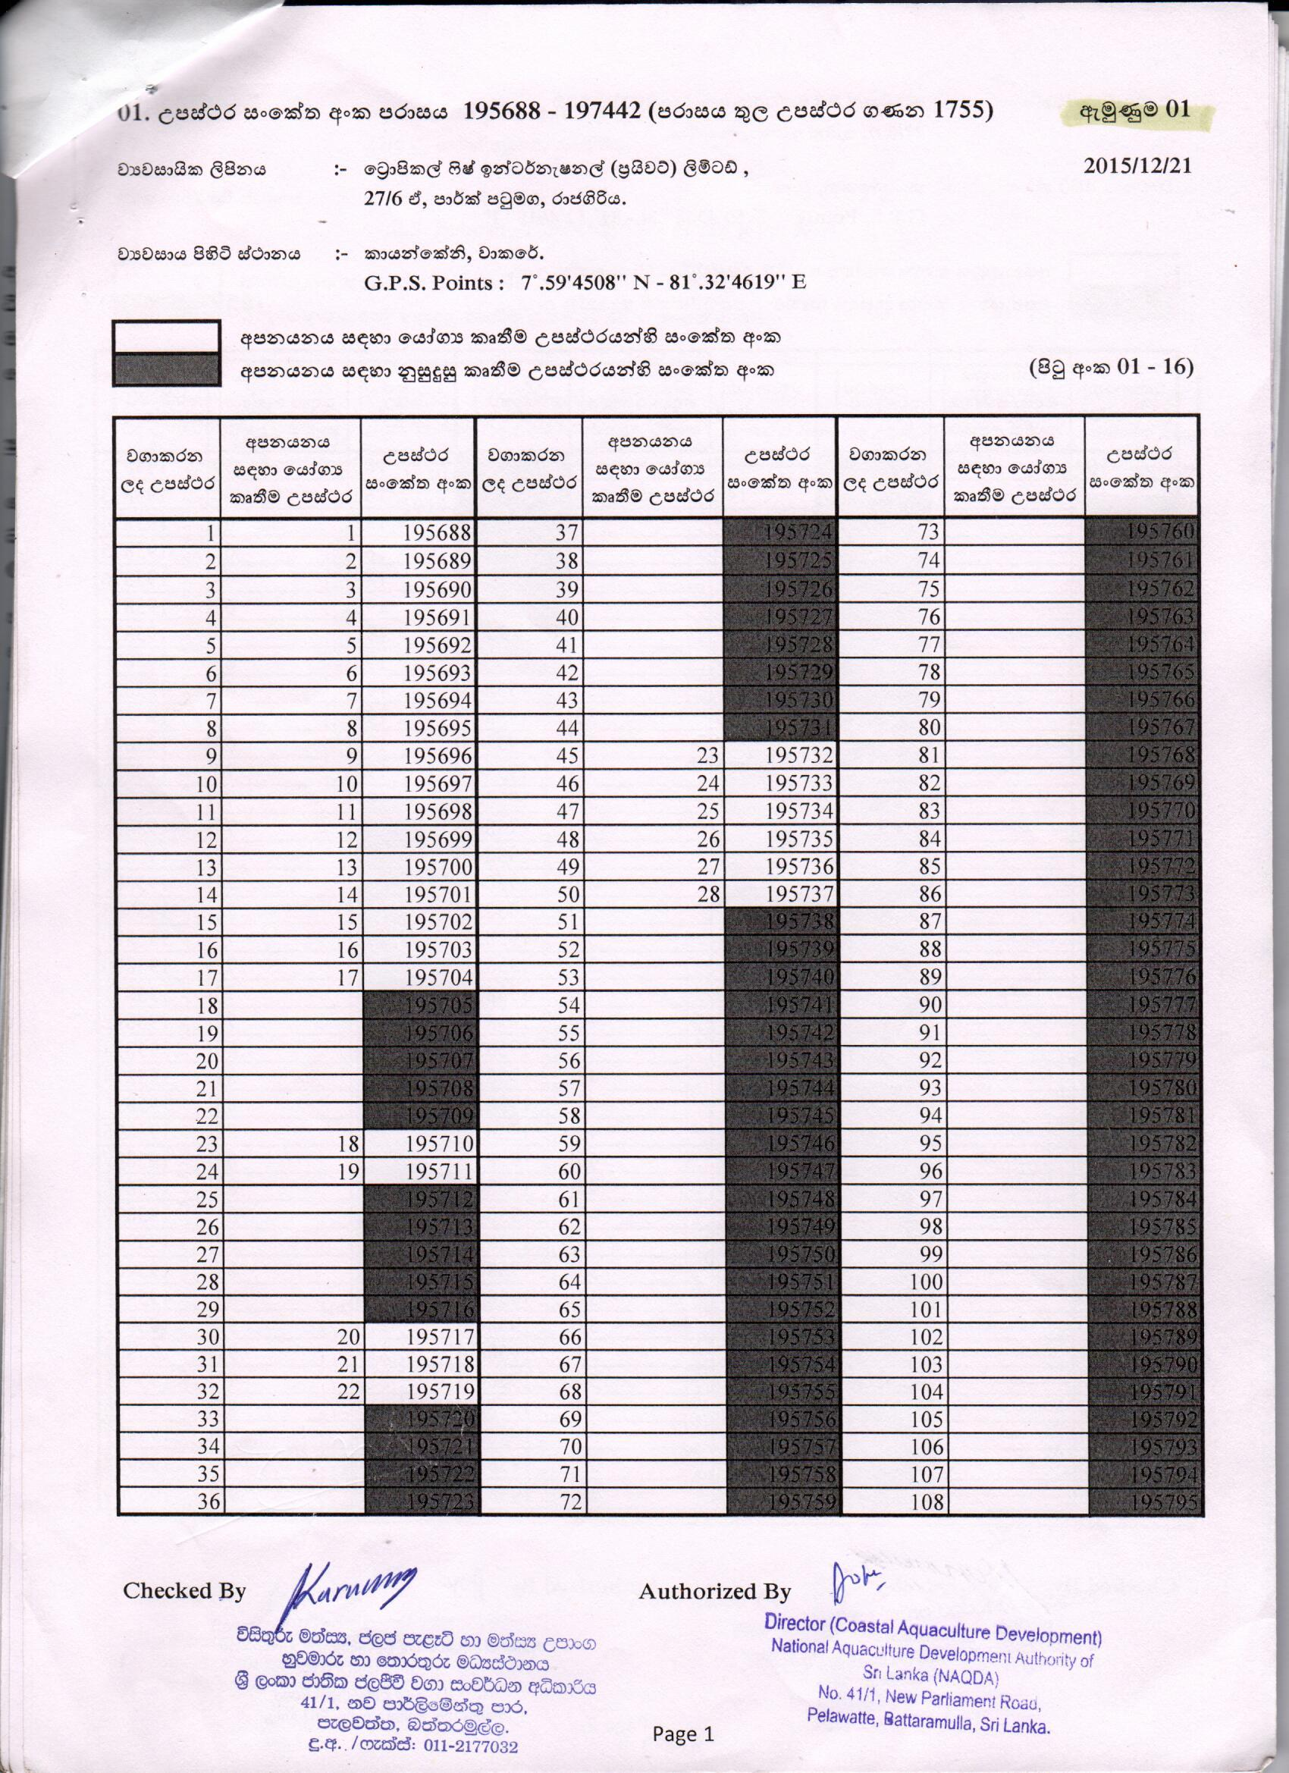

* 1. Documents for previous shipments (CUSDEC, AWB)





1. Fisheries Ministry
   1. Export
2. Filled Application form

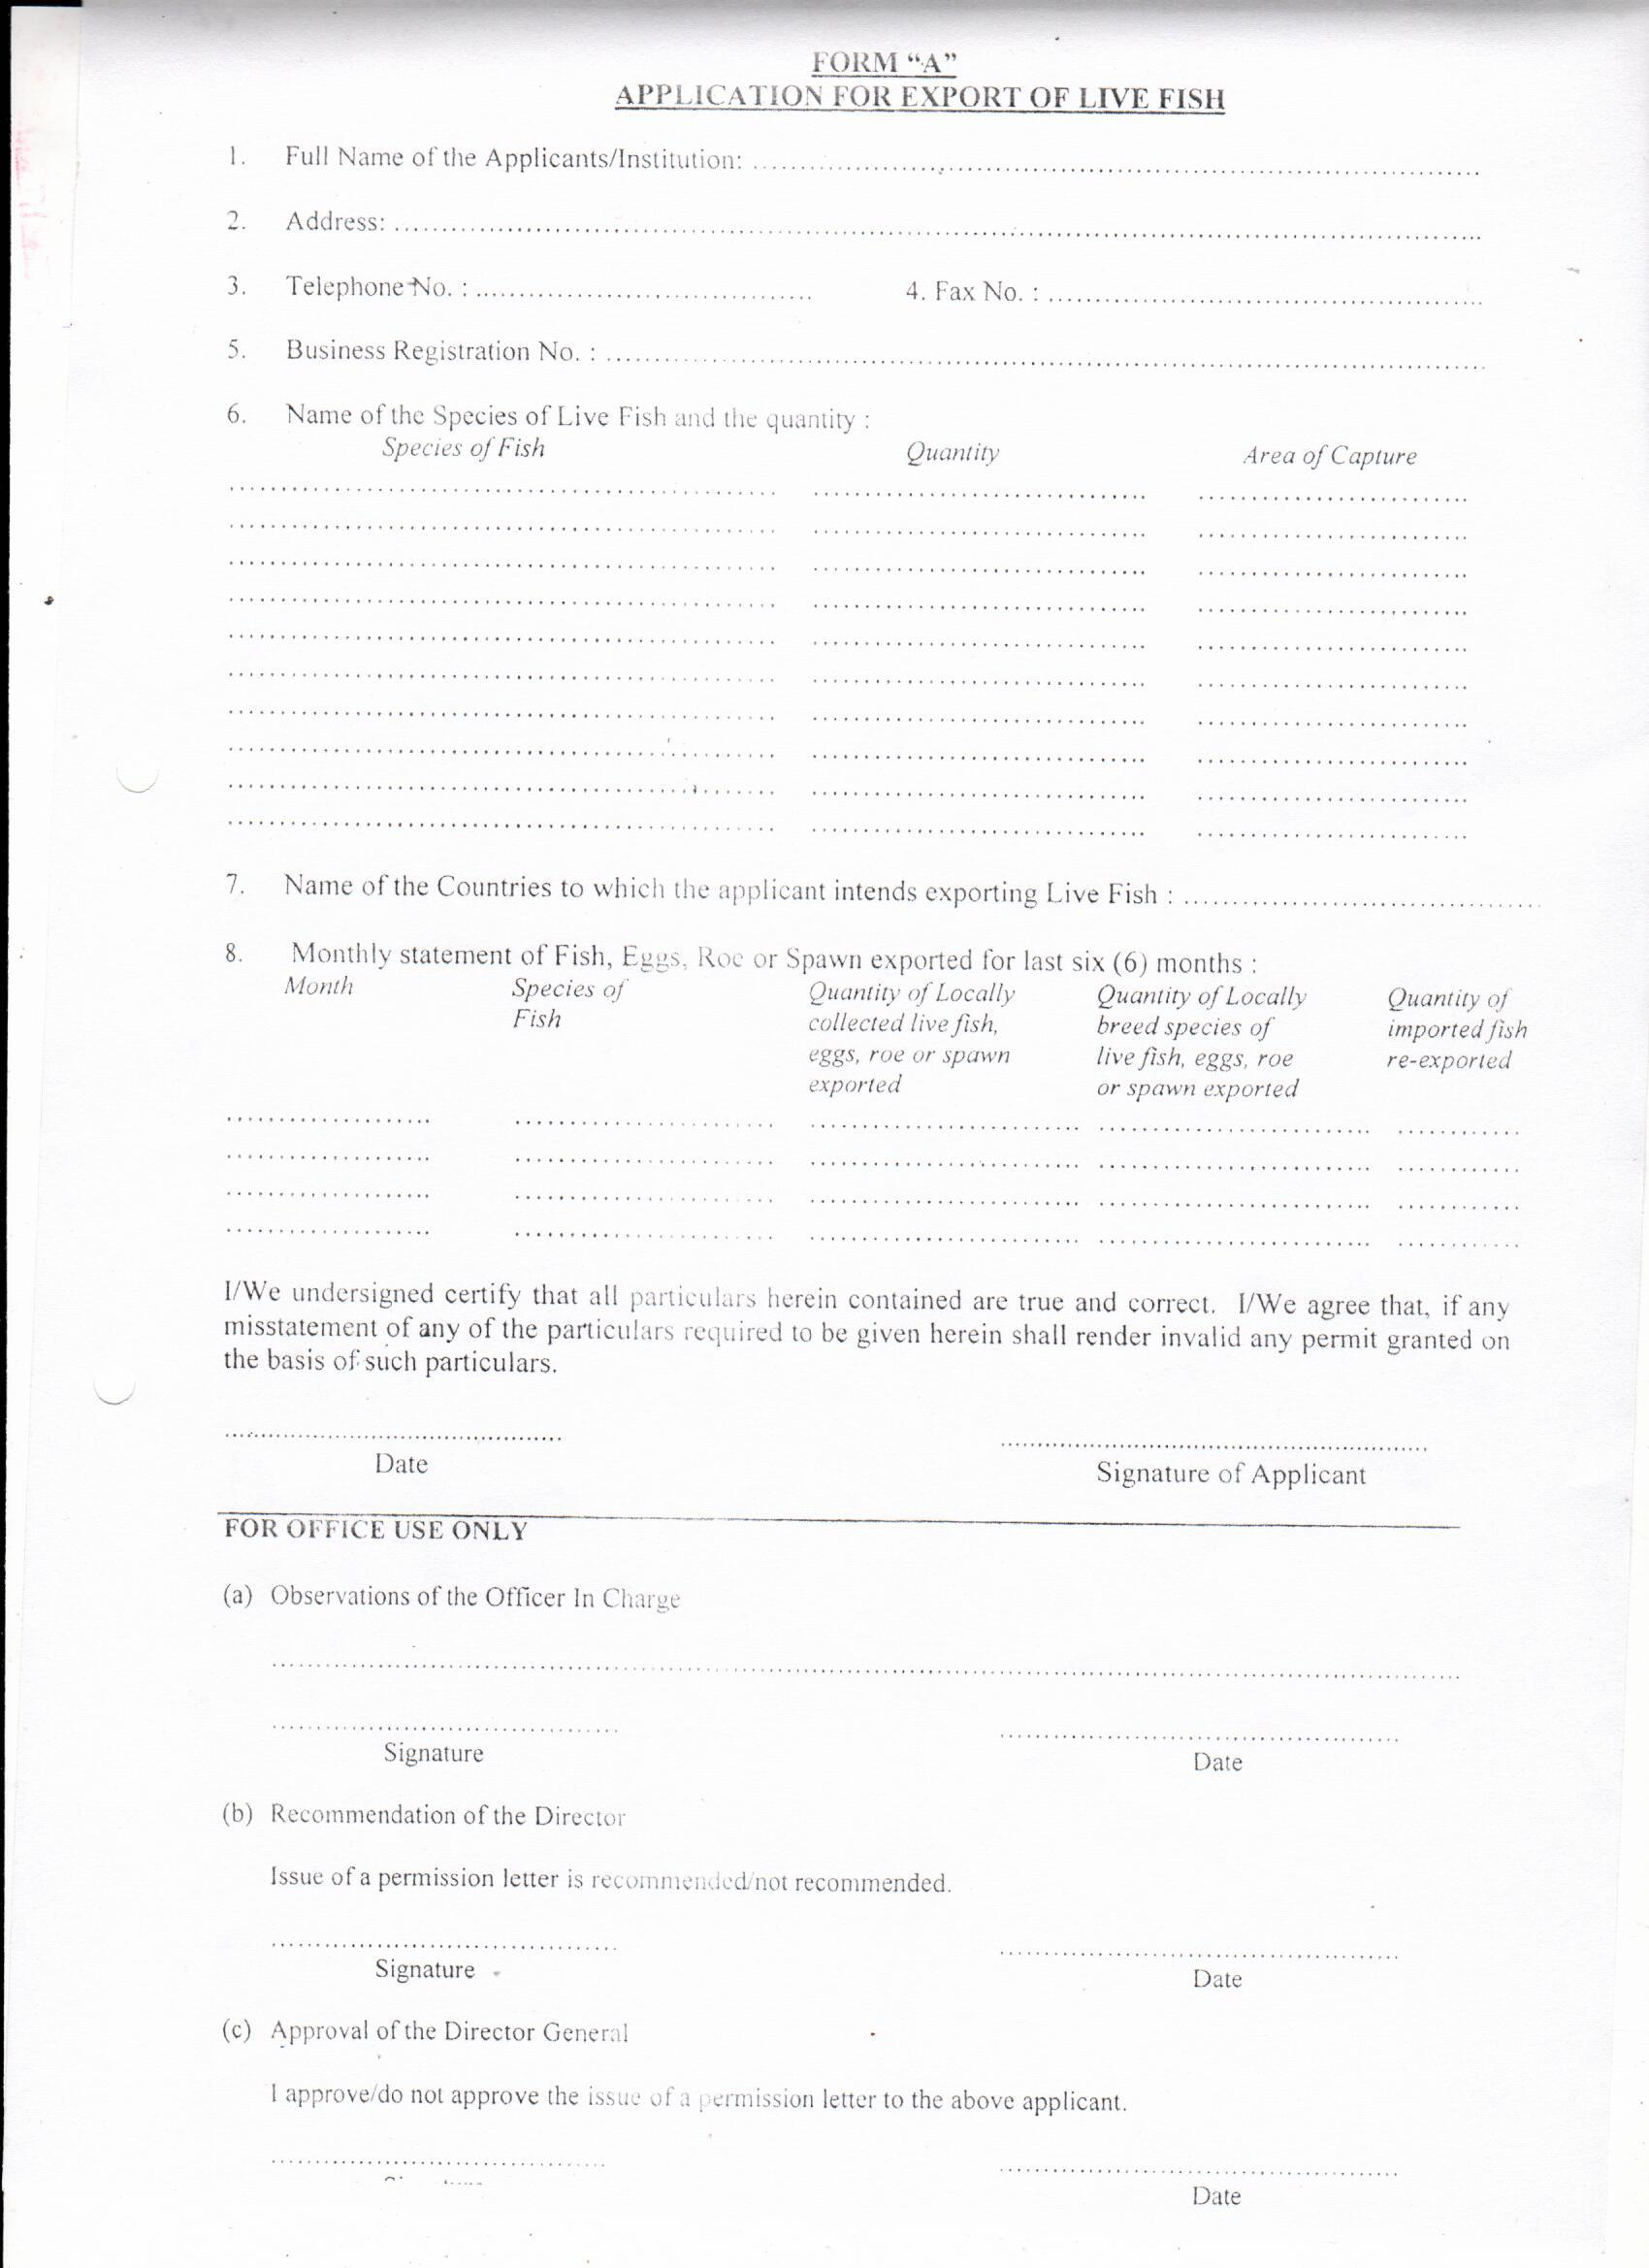

b) Request Letter



c) Import & Export Tracking details

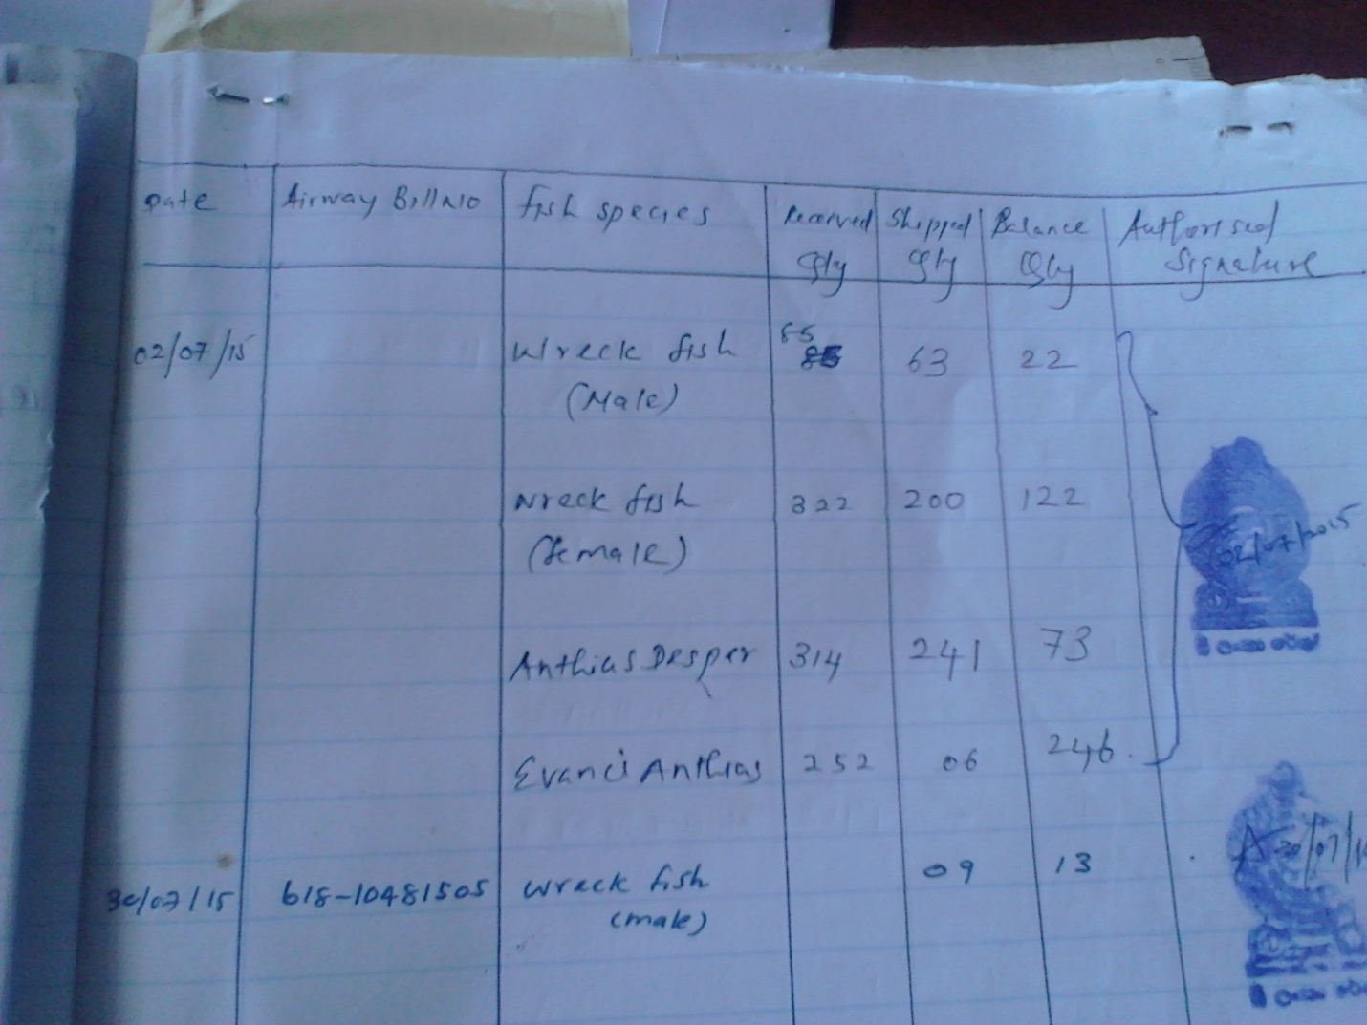

3.2) Import

1. Filled Application form

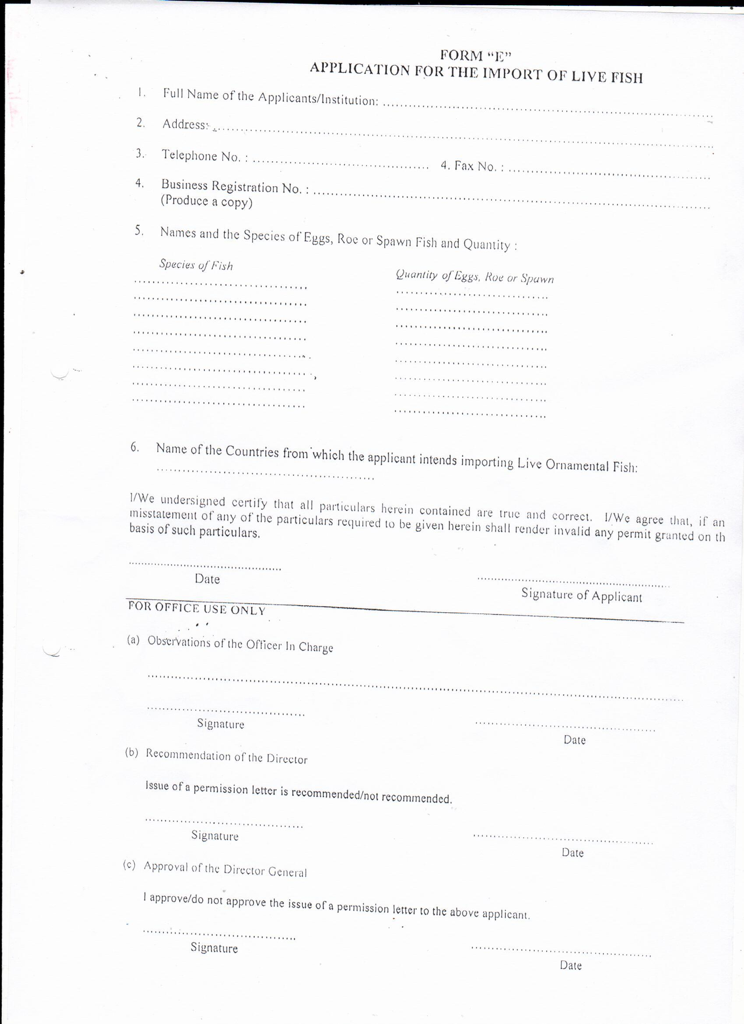

b) Request Letter



c) Import & Export Tracking details



d) CUSDEC, AWB, Invoice





4. DAPH (Import of Fresh water fish for breeding)

